**Q1) Categorize products by stock status**

**---(Display product_name, a new column stock_status whose values are based on below condition units_in_stock = 0 is 'Out of Stock' units_in_stock < 20 is 'Low Stock'**

**Query:**

select * from products --#product_id

select product_name,

case

when units_in_stock = 0 then 'Out of Stock'

when units_in_stock < 20 then 'Low Stock'

else 'High Stock'

end

from products

**Output:**

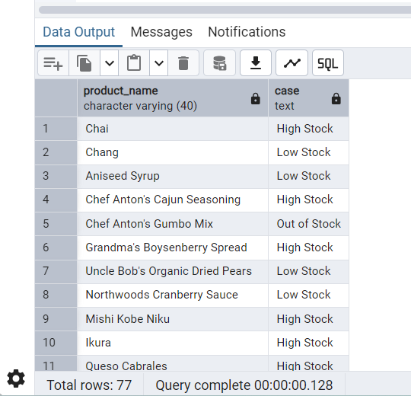

**Q2) Find All Products in Beverages Category (Subquery, Display product_name,unitprice)**

**Query:**

select product_name,unit_price from products where category_id = ALL(select category_id from categories where category_name = 'Beverages')

**Output:**

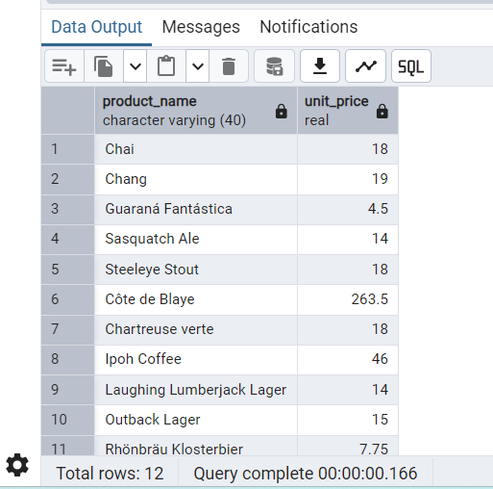

**Q3) Find Orders by Employee with Most Sales**

**---(Display order_id, order_date, freight, employee_id. Employee with Most Sales=Get the total no.of of orders for each employee then order by DESC and limit 1. Use Subquery)**

**Query:**

select o.order_id, o.order_date,o.freight, o.employee_id from orders o where o.employee_id = (select employee_id from orders group by employee_id order by count(*) DESC limit 1 ) order by o.order_date DESC

**Output:**

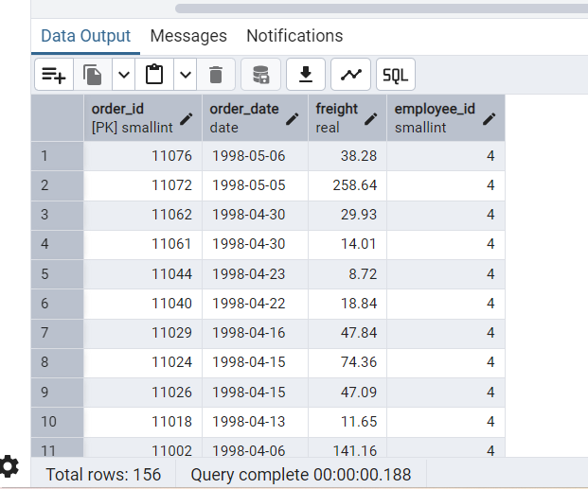

**Q4) Find orders where for country!= ‘USA’ with freight costs higher than any order from USA. (Subquery, Try with ANY, ALL operators)---**

**Query:**

select * from orders--##order_id, ship_country

select * from order_details -- #

select order_id,ship_country,freight from orders where country != 'USA' and freight >

**---ANY Operator**

SELECT order_id,freight FROM orders WHERE ship_country !='USA' AND freight > ANY(

SELECT freight

FROM orders

WHERE ship_country = 'USA'

)

ORDER BY freight;

**Output:**

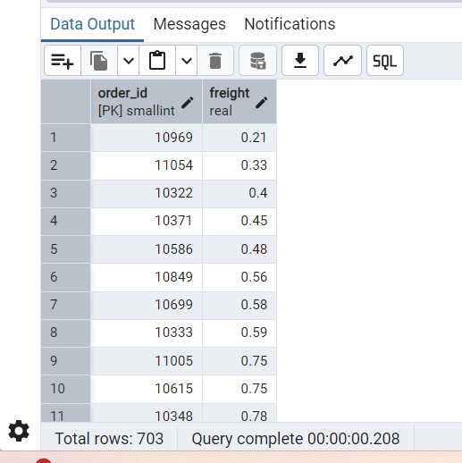

**--ALL Operator**

SELECT order_id, freight FROM orders WHERE ship_country != 'USA' AND freight > ALL (

SELECT freight

FROM orders

WHERE ship_country = 'USA'

)

ORDER BY freight;

**Output:**

